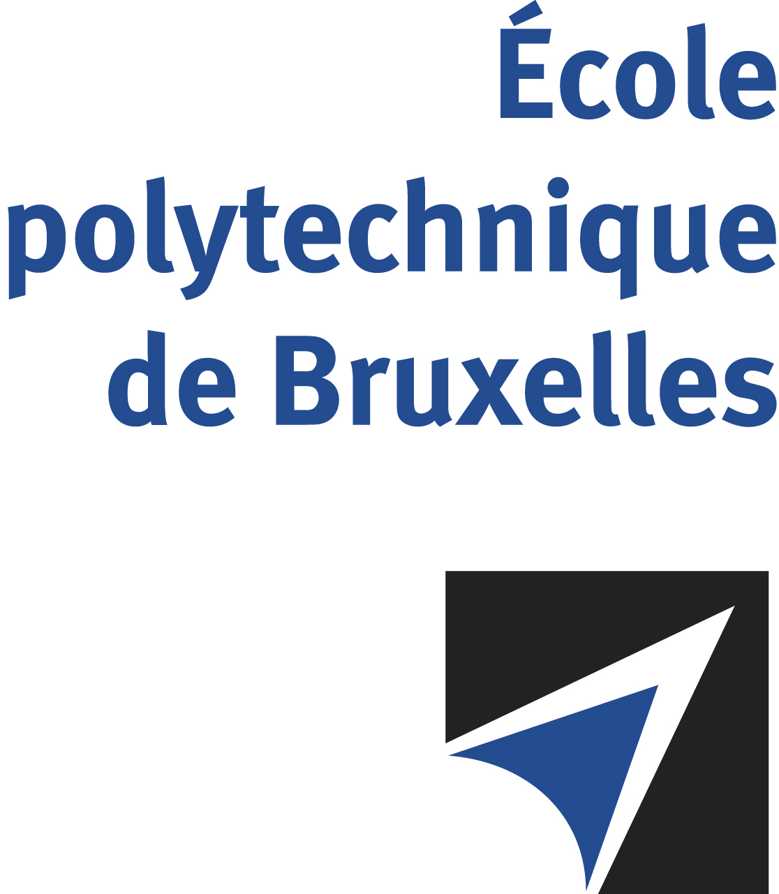

The public defense to obtain the academic degree
of Doctor in Engineering Sciences and Technology
of

Alberto PROCACCI

will be held on

FRIDAY NOVEMBER 29, 2024, AT 3PM
Solbosch Campus
Building R42, 5th level
Room: R42.5.107

The defense will also be held on Teams: https://teams.microsoft.com/l/meetup-join/19%3ameeting_YjUwNDZhNmItMjc3NS00NWRhLTkwMjYtODA1NTI1NWIyYWZi%40thread.v2/0?context=%7b%22Tid%22%3a%2230a5145e-75bd-4212-bb02-8ff9c0ea4ae9%22%2c%22Oid%22%3a%2233e1403d-f93c-4956-8372-e73344543081%22%7d
Mr Alberto PROCACCI

will present and defend in public an original thesis entitled:

Data-Driven Reduced-Order Modelling for the Development of Digital Twins of Combustion Systems

Thesis director : Axel COUSSEMENT
Department : ATM

