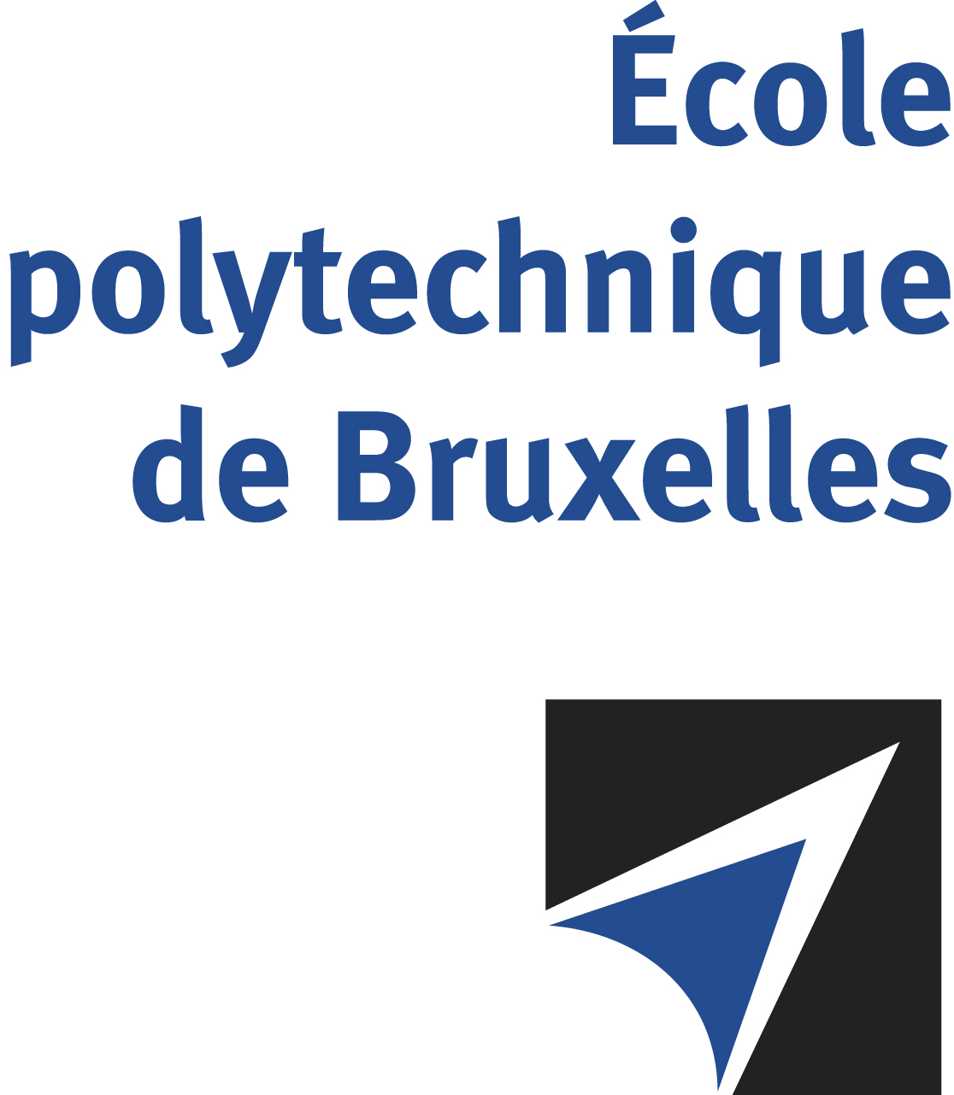

The public defense to obtain the academic degree
of Doctor in Engineering Sciences and Technology
of

Ali NAQI
Nicolas POULVELLARIE
will be held on

FRIDAY DECEMBER 22nd, 2023, AT 10:30AM
Solbosch Campus
Building R42, level 5
Room: R42.5.110

The defense will also be held on Teams: Click here
Mr Ali NAQI

will present and defend in public an original thesis entitled:

Early age characterization of viscoelastic properties
of alkali-activated binders

Thesis director: Stéphanie STAQUET
Department: BATir

