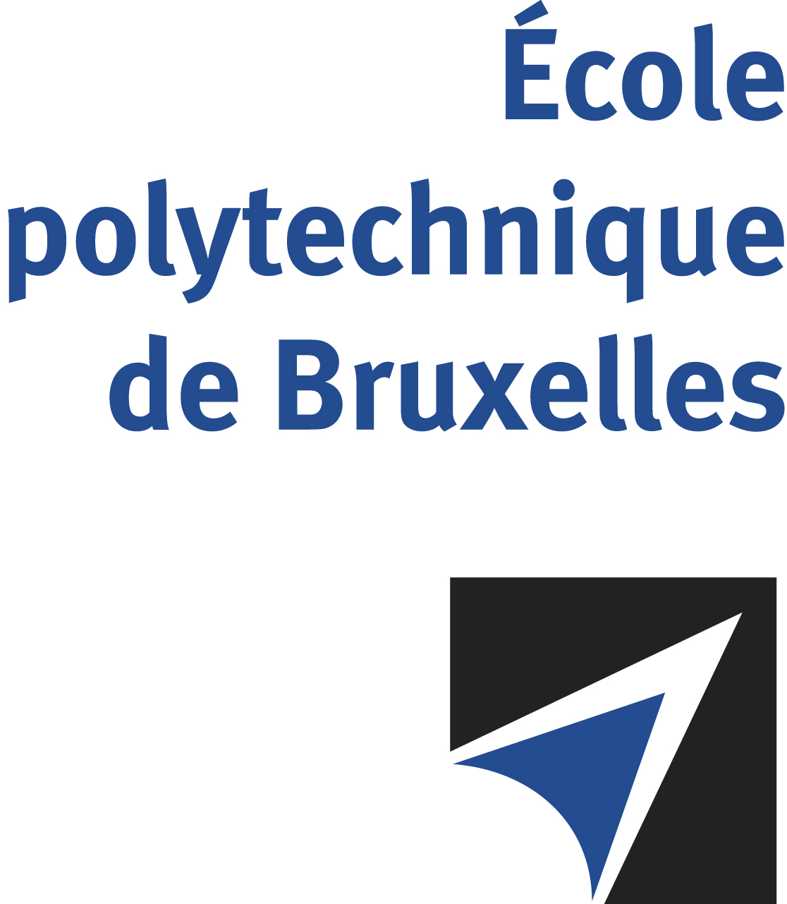

The public defense to obtain the academic degree
of Doctor in Engineering Sciences and Technology
of

Anurag SINGH

will be held on

FRIDAY JULY 12th, 2024, AT 5PM
Solbosch Campus
Building A, 2nd floor
Room: AY2.112

The defense will also be held on Teams: https://teams.microsoft.com/l/meetup-join/19%3ameeting_MTE4MDFkOTEtOGRhMi00MjIzLWIxNDYtN2JmYTRhMjkxNTNh%40thread.v2/0?context=%7b%22Tid%22%3a%2230a5145e-75bd-4212-bb02-8ff9c0ea4ae9%22%2c%22Oid%22%3a%2263f688ac-89f2-4d29-aef7-9f3852467349%22%7d

Mr Anurag SINGH

will present and defend in public an original thesis entitled:

Synthesis and studies of synthetic anion transporters using unconventional non-covalent interactions for the selective transport of chloride

Thesis director: Hennie VALKENIER-VAN DIJK
Department: Engineering of Molecular NanoSystems (EMNS)

