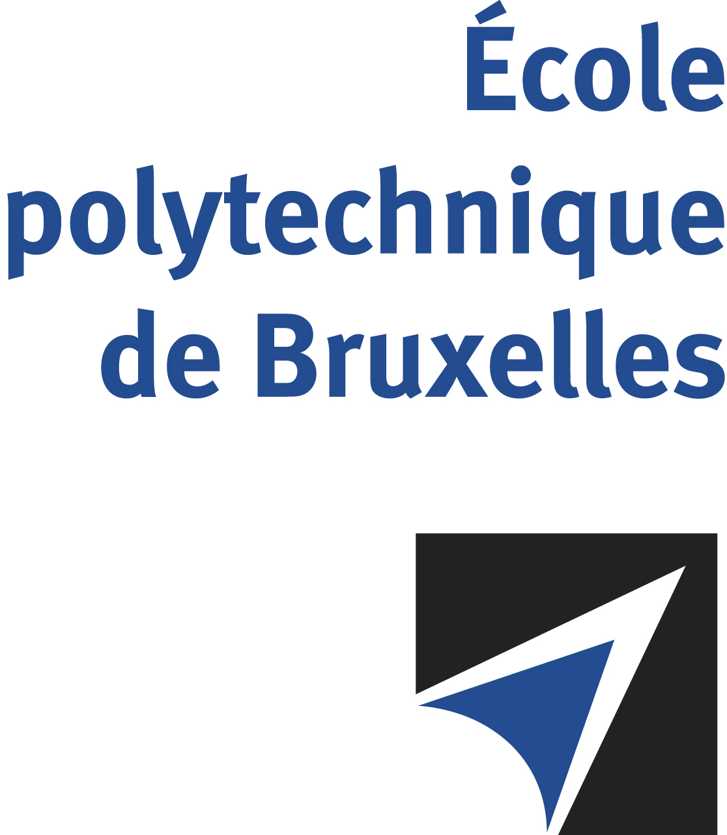

The public defense to obtain the academic degree
of Doctor in Engineering Sciences and Technology
of

Benjamin WAUTHION

will be held on

FRIDAY DECEMBER 15, 2023, AT 5PM
Solbosch Campus
Auditore Roger Lallemand
Room: B1.315

The defense will also be held on Teams: https://teams.microsoft.com/l/meetup-join/19%3ameeting_MjRlMTVmYWYtZDc0Ni00ZGEzLWJlYjYtYzM2ODljY2U0YWRi%40thread.v2/0?context=%7b%22Tid%22%3a%2230a5145e-75bd-4212-bb02-8ff9c0ea4ae9%22%2c%22Oid%22%3a%2265cb7ff5-9aab-4394-a37c-4dcf03380915%22%7d

Mr Benjamin WAUTHION

will present and defend in public an original thesis entitled:

Health Monitoring of an Electromechanical Flight Surface Actuator

Thesis director: Michel KINNAERT
Thesis co-director: Emanuele GARONE
Department : Unité de recherche en Automatique et Analyse des Systèmes

