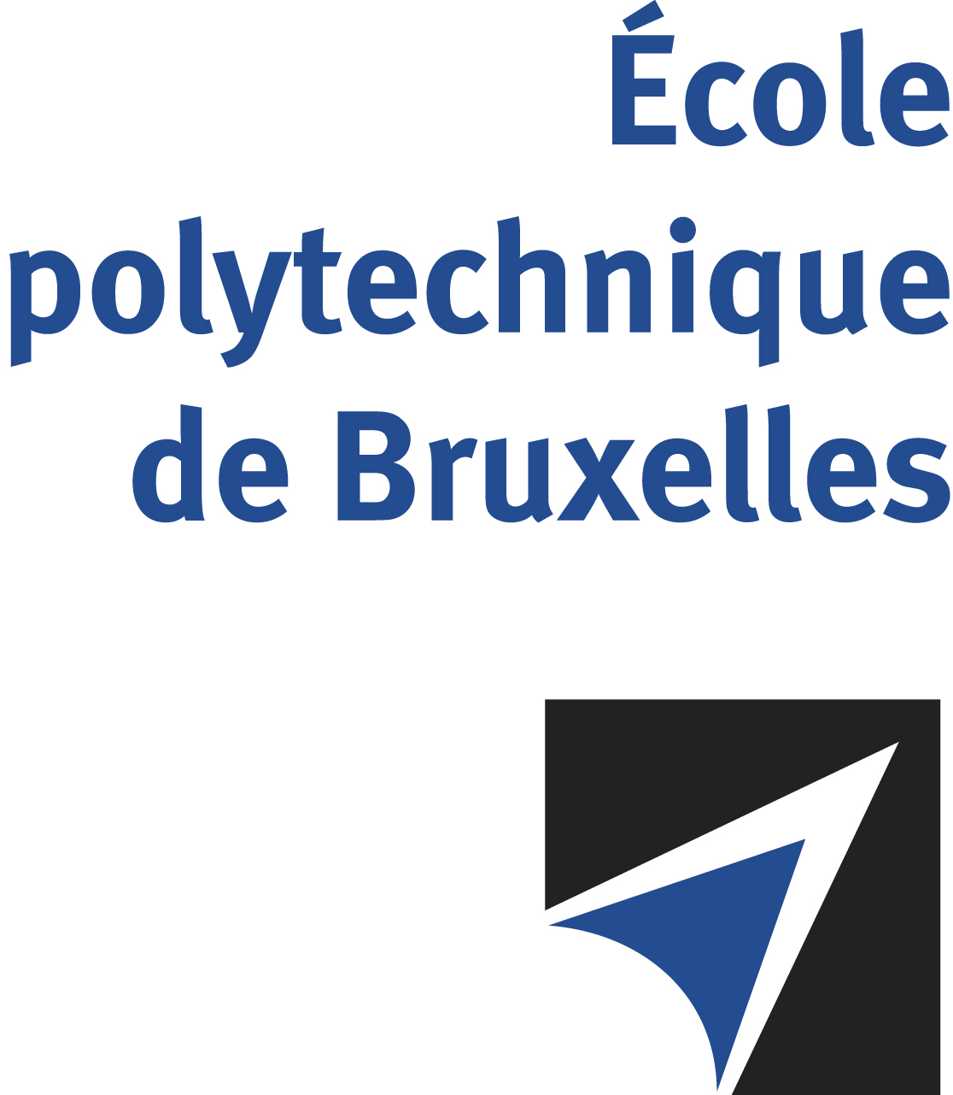

JOINT SUPERVISION
Université libre de Bruxelles – Universitat Politècnica de Catalunya

The public defense to obtain the academic degree
of Doctor in Engineering Sciences and Technology

of
Joan BOTEY BASSOLS
Nico Joan BOTEY i BASSOLS las POULVELLARIE
will be held on
FRIDAY FEBRUARY 2, 2024, AT 11:00 AM

Universitat Politècnica de Catalunya - BarcelonaTech
Building C1, room C1-002 (Sala de Tesines)
Carrer de Jordi Girona, 1-3, 08034 Barcelona

The defense will also be held on Google meet: https://meet.google.com/rbx-jtei-rhn

Mr Joan BOTEY BASSOLS

will present and defend in public an original thesis entitled:

Exploring the potential of satellite InSAR in Geological Engineering: new opportunities in land monitoring and hydrogeological characterization

Thesis director: Pierre GERARD
UPC thesis co-director: Nieves LANTADA ZARZOSA
Department: BATir

