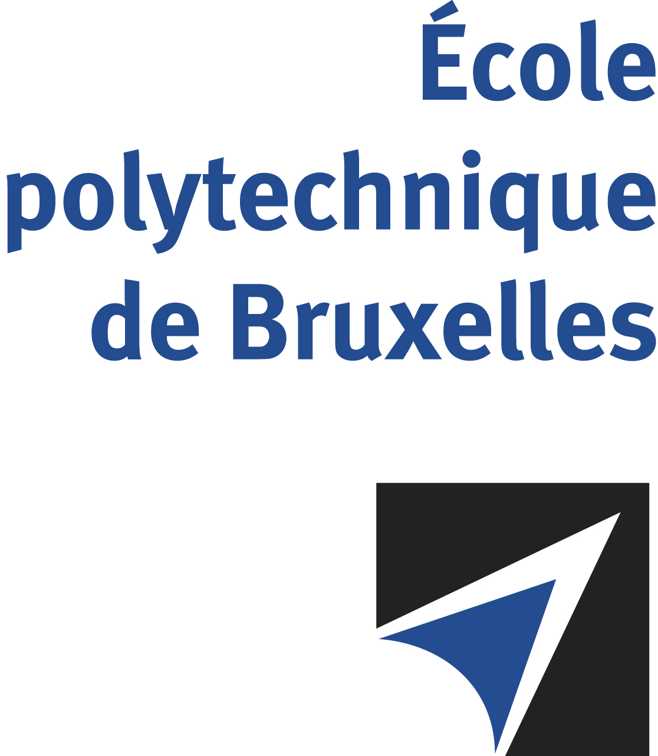

The public defense to obtain the academic degree
of Doctor in Engineering Sciences and Technology
of

Eve-Line CADOTTE

will be held on

FRIDAY OCTOBER 11, 2024, AT 4:15PM
Solbosch Campus
Building U, gate B, 2nd floor
Room: UB2.147

The defense will also be held on Teams: Soutenance Eve-Line CADOTTE
Ms Eve-Line CADOTTE

will present and defend in public an original thesis entitled:

The development of microstructure and mechanical properties
in Q&P steels: effect of manganese

Thesis director: Stéphane GODET
Department: 4MAT

