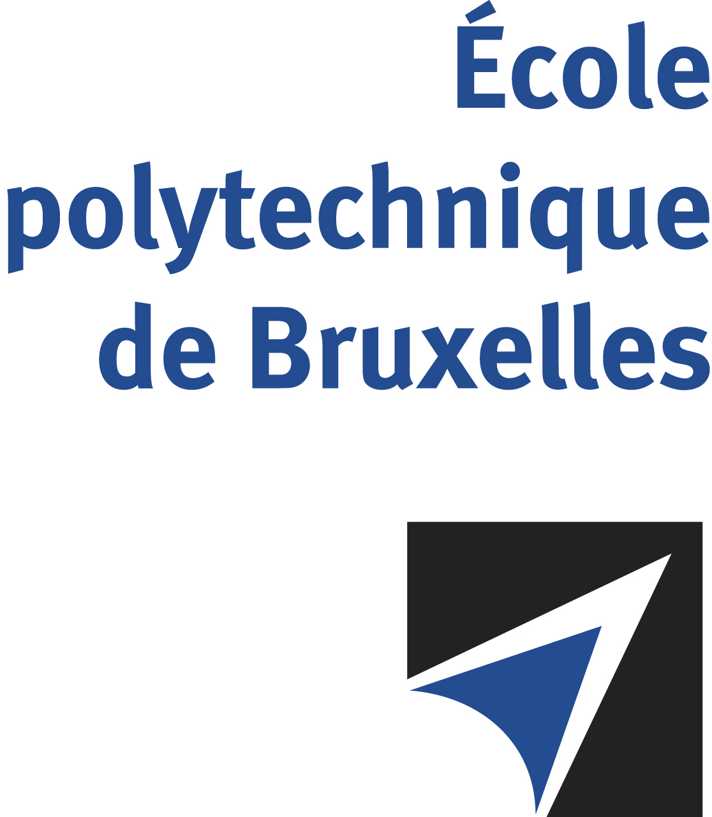

The public defense to obtain the academic degree
of Doctor in Engineering Sciences and Technology
of

Clément RIGAUT
P
will be held on

TUESDAY DECEMBER 17, 2024, AT 4PM
Solbosch Campus
Building K, 4th floor
Room: K.4.401

The defense will also be held on Teams: https://teams.microsoft.com/l/meetup-join/19%3ameeting_MjVmYjc3ODUtNWY0Zi00MDBlLTkzNjMtOWE4YjRmNzM4MzQ5%40thread.v2/0?context=%7b%22Tid%22%3a%2230a5145e-75bd-4212-bb02-8ff9c0ea4ae9%22%2c%22Oid%22%3a%22bedc399e-448a-49ce-8fbf-7e3f8373aa69%22%7d
Mr Clément RIGAUT

will present and defend in public an original thesis entitled:

The Nose as a Pathway to the Brain and Body. Experimental and Computational Models of the Nasal Cavity

Thesis director: Pierre LAMBERT
Thesis co-director: Benoit HAUT
Department: TIPs

