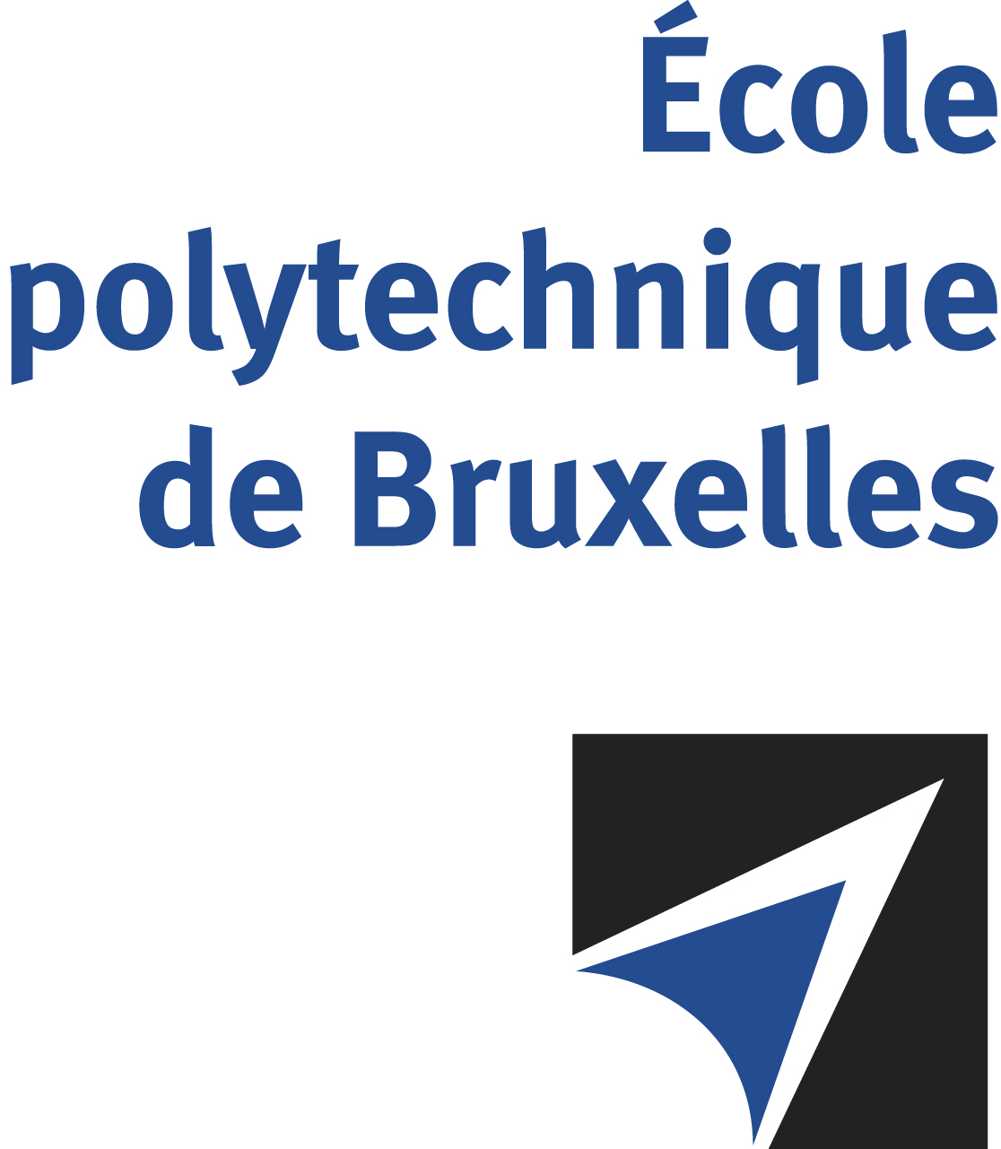

JOINT SUPERVISION
Université libre de Bruxelles – Vrije Universiteit Brussel

The public defense to obtain the academic degree
of Doctor in Engineering Sciences and Technology

of
Daniele BONATTO
Nicolas POULVELLARIE
will be held on

THURSDAY MARCH 7, 2024, AT 4PM
Solbosch Campus
Building U, 6th floor
Room: UD6.215
The defense will also be held on Teams: https://teams.microsoft.com/l/meetup-join/19%3ameeting_NjhhNWI0MzItZDVkMS00NWMwLWE3ZGEtYTg0ZmNkYjdjNGI3%40thread.v2/0?context=%7b%22Tid%22%3a%2230a5145e-75bd-4212-bb02-8ff9c0ea4ae9%22%2c%22Oid%22%3a%22cd31af98-2f75-4194-afc8-0879d5bc0d03%22%7d
Meeting ID: 335 617 528 749 Passcode: rWQodh

Mr Daniele BONATTO

will present and defend in public an original thesis entitled:

From multi-modal capture to photo-realistic view synthesis: A high-quality and real-time multiview approach

Thesis director: Gauthier LAFRUIT
VUB thesis co-director: Adrian MUNTEANU
Department: LISA

