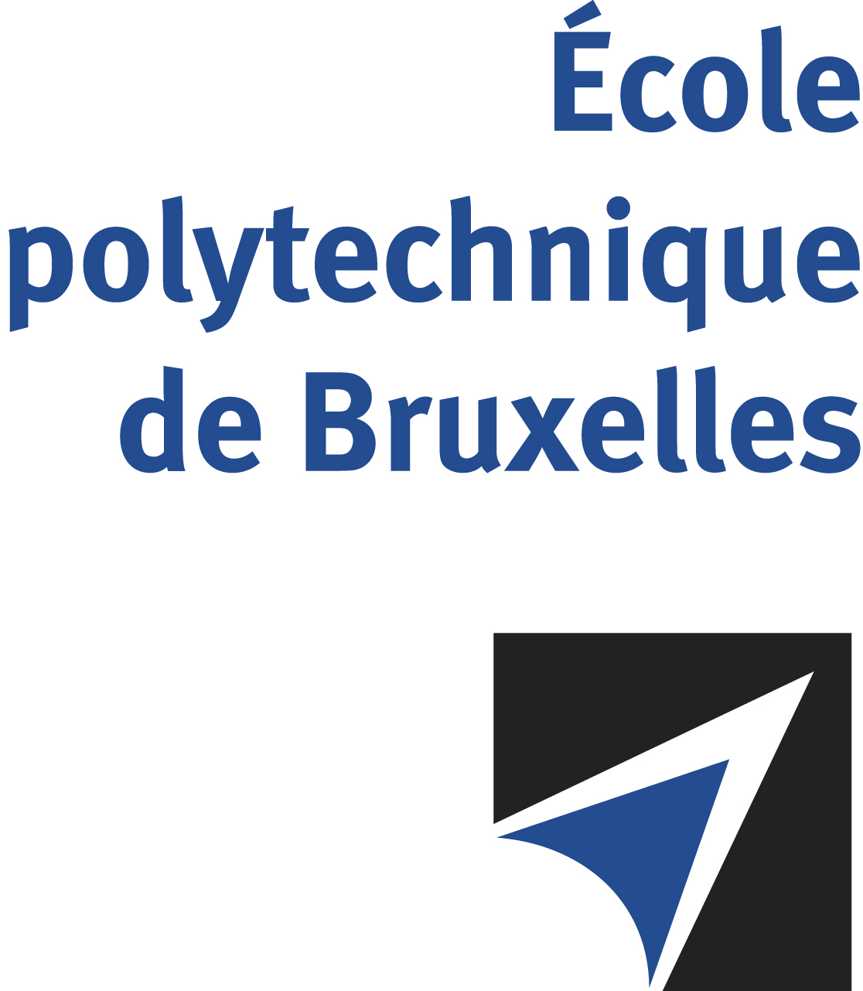

The public defense to obtain the academic degree
of Doctor in Engineering Sciences and Technology
of

Adriana ENACHE

will be held on

WEDNESDAY APRIL 16, 2025, AT 3PM
Solbosch Campus
Building B, Room: B1.315

The defense will also be held on Teams: Join the meeting now
Meeting ID: 378 496 718 51 Passcode: Pu7Gm9iY
Ms Adriana ENACHE

will present and defend in public an original thesis entitled:

Analytical and Experimental Investigation of De-Icing Phenomena on Airfoils

Thesis director: Patrick HENDRICK
Thesis co-director: Jeroen VAN BEECK (VKI)
Department: ATM

