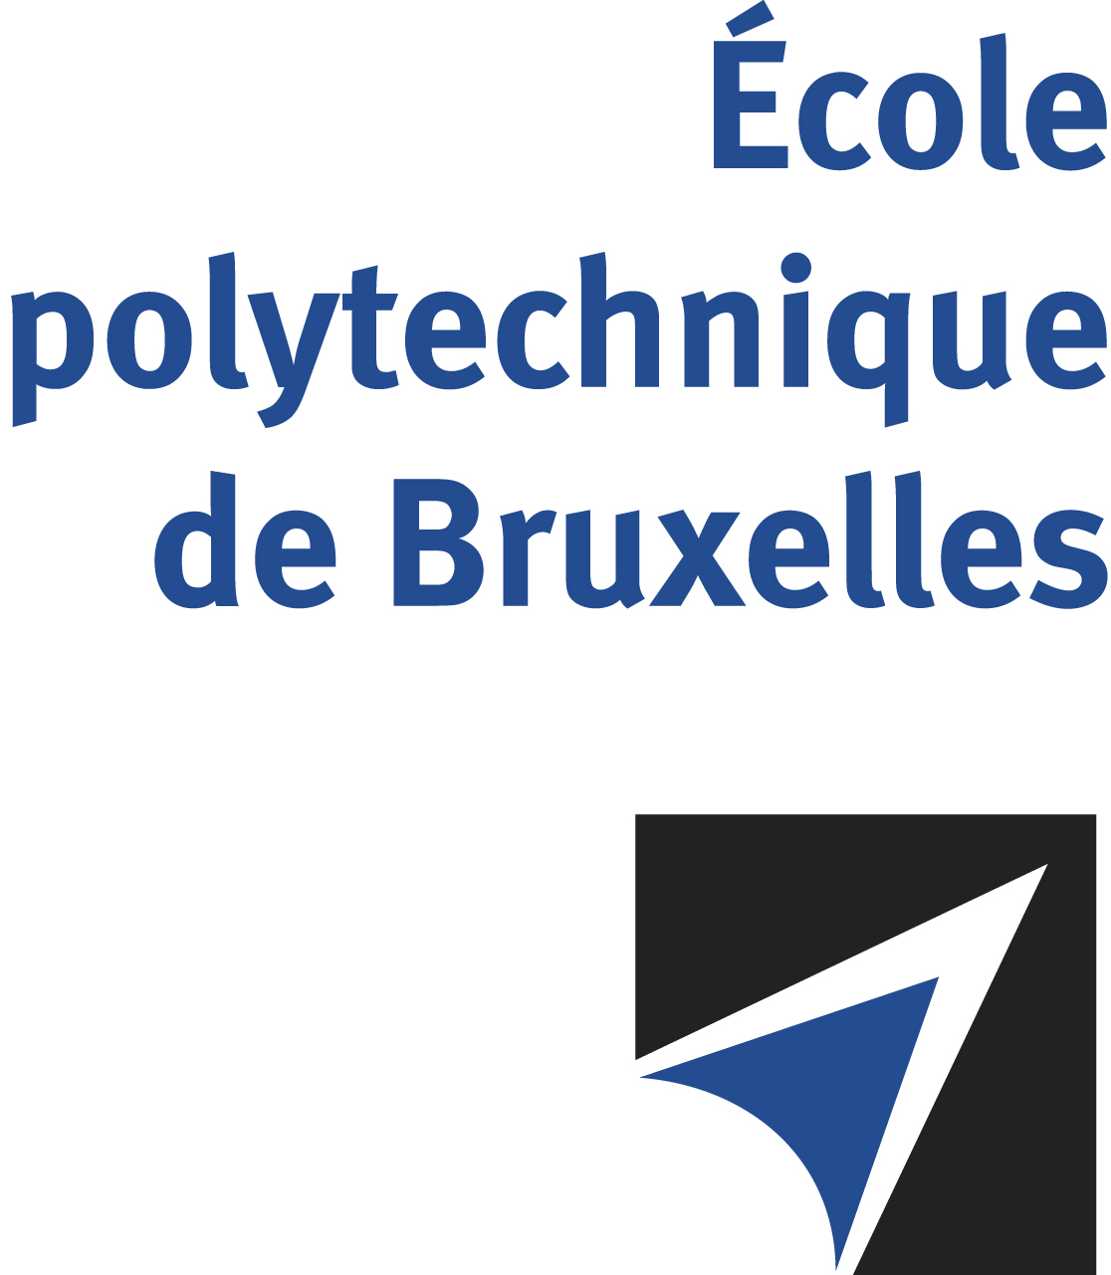

The public defense to obtain the academic degree
of Doctor in Engineering Sciences and Technology
of

Evert POCOMA COPA

will be held on

MONDAY FEBRUARY 26, 2024, AT 4PM
Solbosch Campus
Building R42, 5th floor
Room: R42.5.110

The defense will also be held on Teams: https://shorturl.at/qHMPU
Mr Evert POCOMA COPA

will present and defend in public an original thesis entitled:

Distributed Direct Localization and Tracking of Wireless Transmitters

Thesis director: François HORLIN
Thesis co-director: François QUITIN
Department: OPERA

