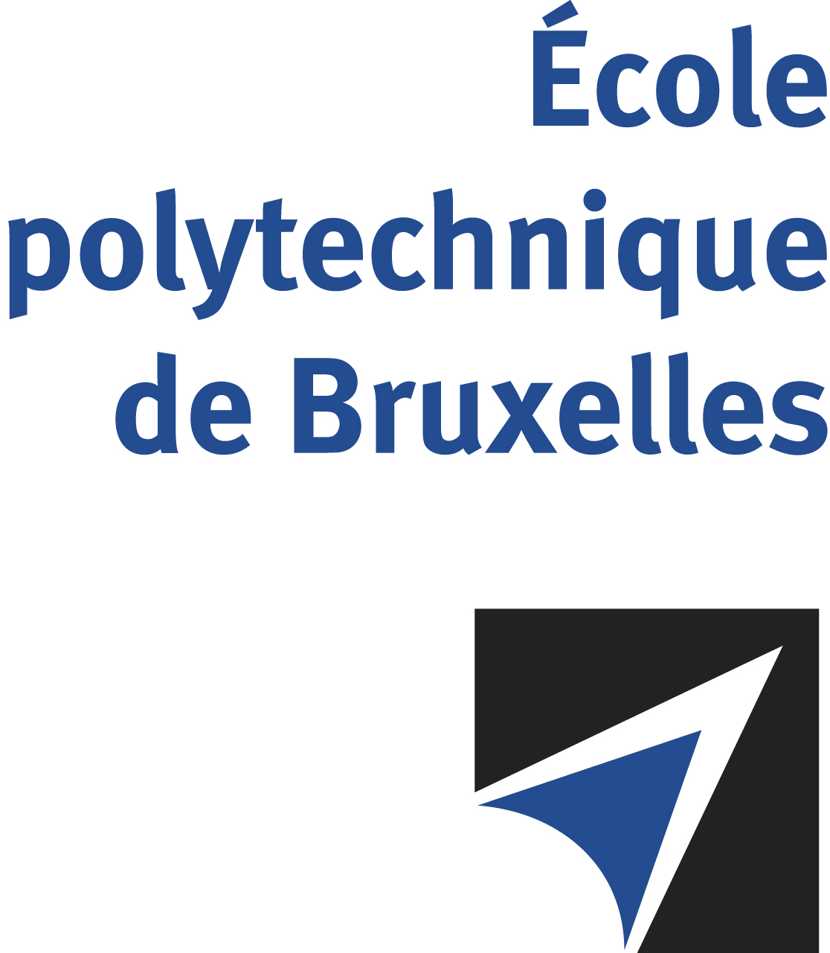

The public defense to obtain the academic degree
of Doctor in Engineering Sciences and Technology
of

Sedjro GNACADJA
will be held on

FRIDAY OCTOBER 27, 2023, AT 4.30PM
Solbosch Campus
Building R42
Room: R42.5.103

The defense will also be held on Teams: http://bit.ly/3Q4lHy5

Mr Sedjro GNACADJA

will present and defend in public an original thesis entitled:

Monte Carlo optimization of beam properties and dose conformation of small field proton therapy beamlines for beyond state of the art eye treatment

Thesis director: Nicolas PAULY
Department: Métrologie nucléaire

