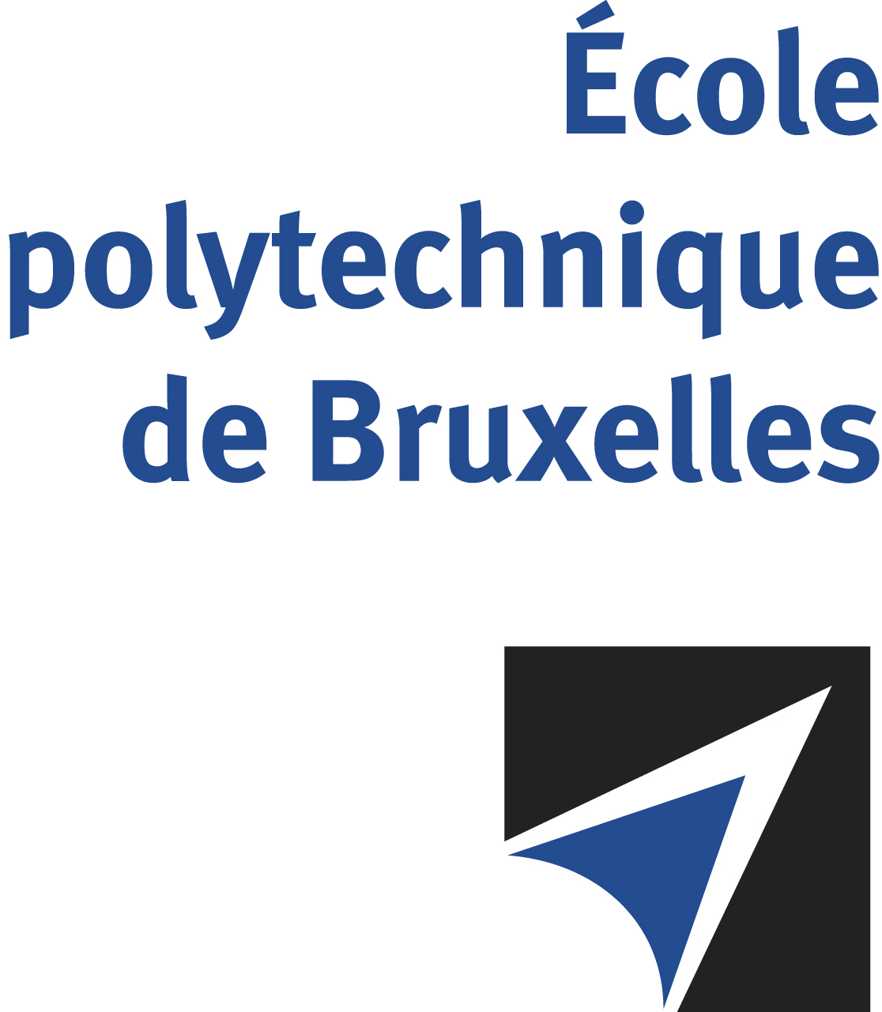

The public defense to obtain the academic degree
of Doctor in Engineering Sciences and Technology
of

Kevin PRZEPIORA

will be held on

MONDAY JUNE 24, 2024, AT 4.30PM
Solbosch Campus
Building D, 2nd floor
Room: DC2.206

The defense will also be held on Teams: Join the meeting now
Meeting ID: 371 526 720 029 Passcode: ZfpSaG
Mr Kevin PRZEPIORA

will present and defend in public an original thesis entitled:

Phase Separation in soda-lime glasses: From microstructure control
to the relationships with optical and mechanical properties

Thesis director: Stephane GODET
Department: 4MAT

