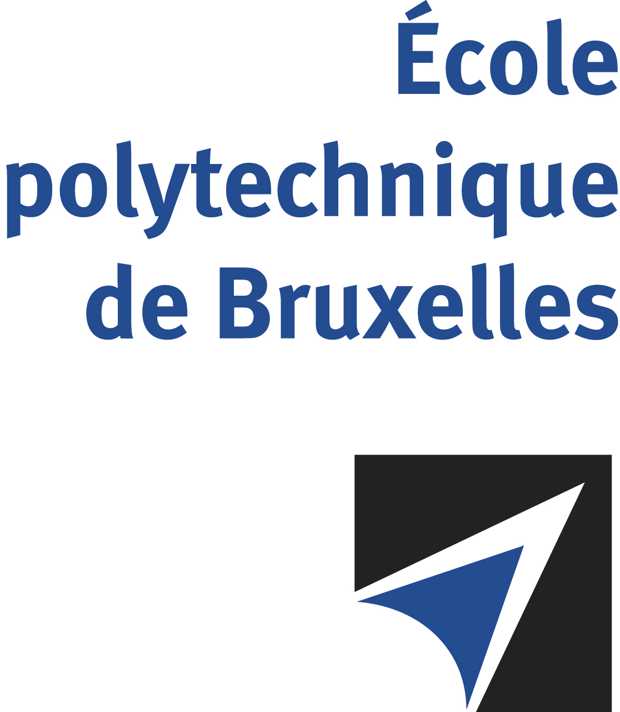

JOINT SUPERVISION
Université libre de Bruxelles – Université de Mons

The public defense to obtain the academic degree
of Doctor in Engineering Sciences and Technology

of
Matteo SAVARESE
Nico Joan BOTEY i BASSOLS las POULVELLARIE
will be held on
WEDNESDAY NOVEMBER 27, 2024, AT 4:00 PM
Solbosch Campus
Building U, gate D, 6th floor
Room: UD6.211

The defense will also be held on Teams: https://teams.microsoft.com/l/meetup-join/19%3ameeting_OWVkYTkxMTgtMWRmNi00Njk4LWE3NjktNWE2MzRhZWYxMGRm%40thread.v2/0?context=%7b%22Tid%22%3a%2230a5145e-75bd-4212-bb02-8ff9c0ea4ae9%22%2c%22Oid%22%3a%221f4212f3-51b4-466e-b712-55d0d3dd4609%22%7d
Mr Matteo SAVARESE

will present and defend in public an original thesis entitled:

Physics-based, reduced-order-modeling of combustion systems: design and applications

Thesis director: Alessandro PARENTE
UMONS thesis co-director: Ward DE PAEPE
Department: ATM

