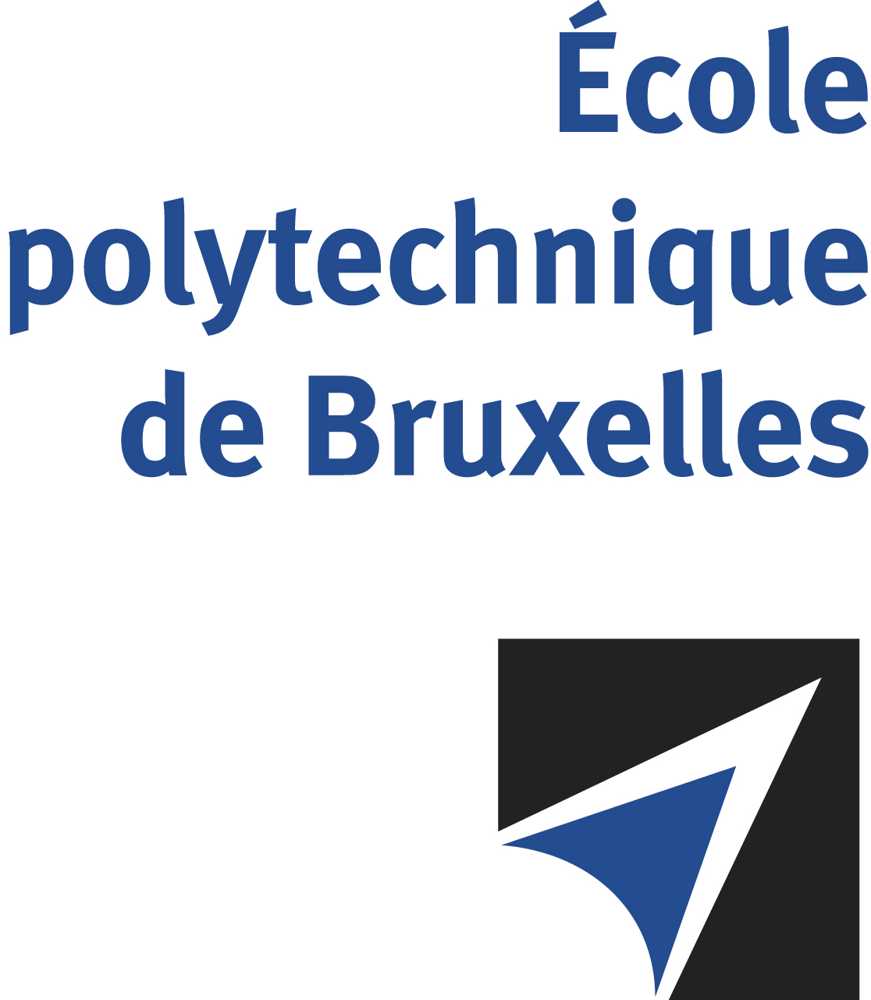

The public defense to obtain the academic degree
of Doctor in Engineering Sciences and Technology
of

Mizuki OKADA

will be held on

FRIDAY APRIL 26, 2024, AT 3PM
Solbosch Campus
Building C, 4th floor
Room: C4.219

The defense will also be held on Teams: https://teams.microsoft.com/l/meetup-join/19%3ameeting_YzkwNTIyYWUtN2M0My00MjRlLWIxZmQtN2E1ZmQxYTRkNDEy%40thread.v2/0?context=%7b%22Tid%22%3a%2230a5145e-75bd-4212-bb02-8ff9c0ea4ae9%22%2c%22Oid%22%3a%2234867407-9492-463e-b9a5-bb6860b2f7b7%22%7d

Mr Mizuki OKADA

will present and defend in public an original thesis entitled:

Implementation of Particle Image Velocimetry for Turbomachinery Flows

Thesis director: Alessandro PARENTE
Thesis co-director: Sergio LAVAGNOLI (VKI)
Department: ATM

