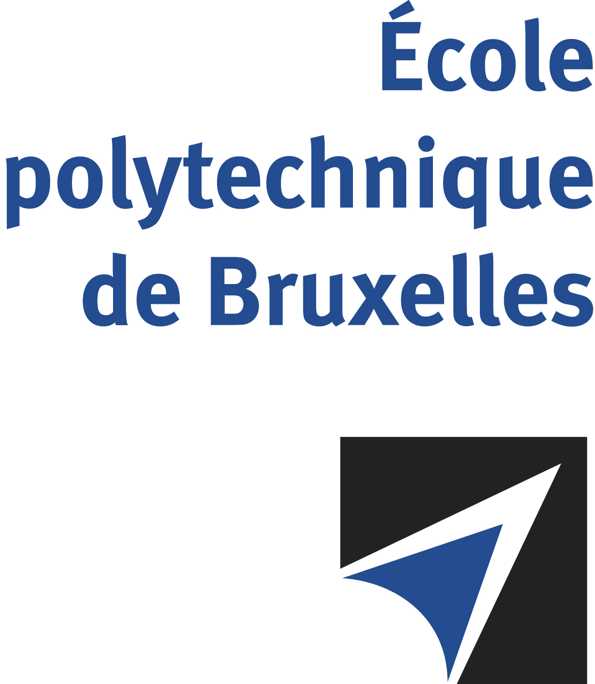

The public defense to obtain the academic degree
of Doctor in Engineering Sciences and Technology
of

Muhammad SALMAN

will be held on

FRIDAY AUGUST 30, 2024, AT 5:30PM
Solbosch Campus
Building R42, 5th floor
Room: R42.5.110

The defense will also be held on Teams: Join the meeting now
Meeting ID: 393 676 063 340 Passcode: 2jH7Vf
Mr Muhammad SALMAN

will present and defend in public an original thesis entitled:

Automatic design of pheromone-based stigmergy in robot swarms

Thesis director: Mauro BIRATTARI
Department: IRIDIA

