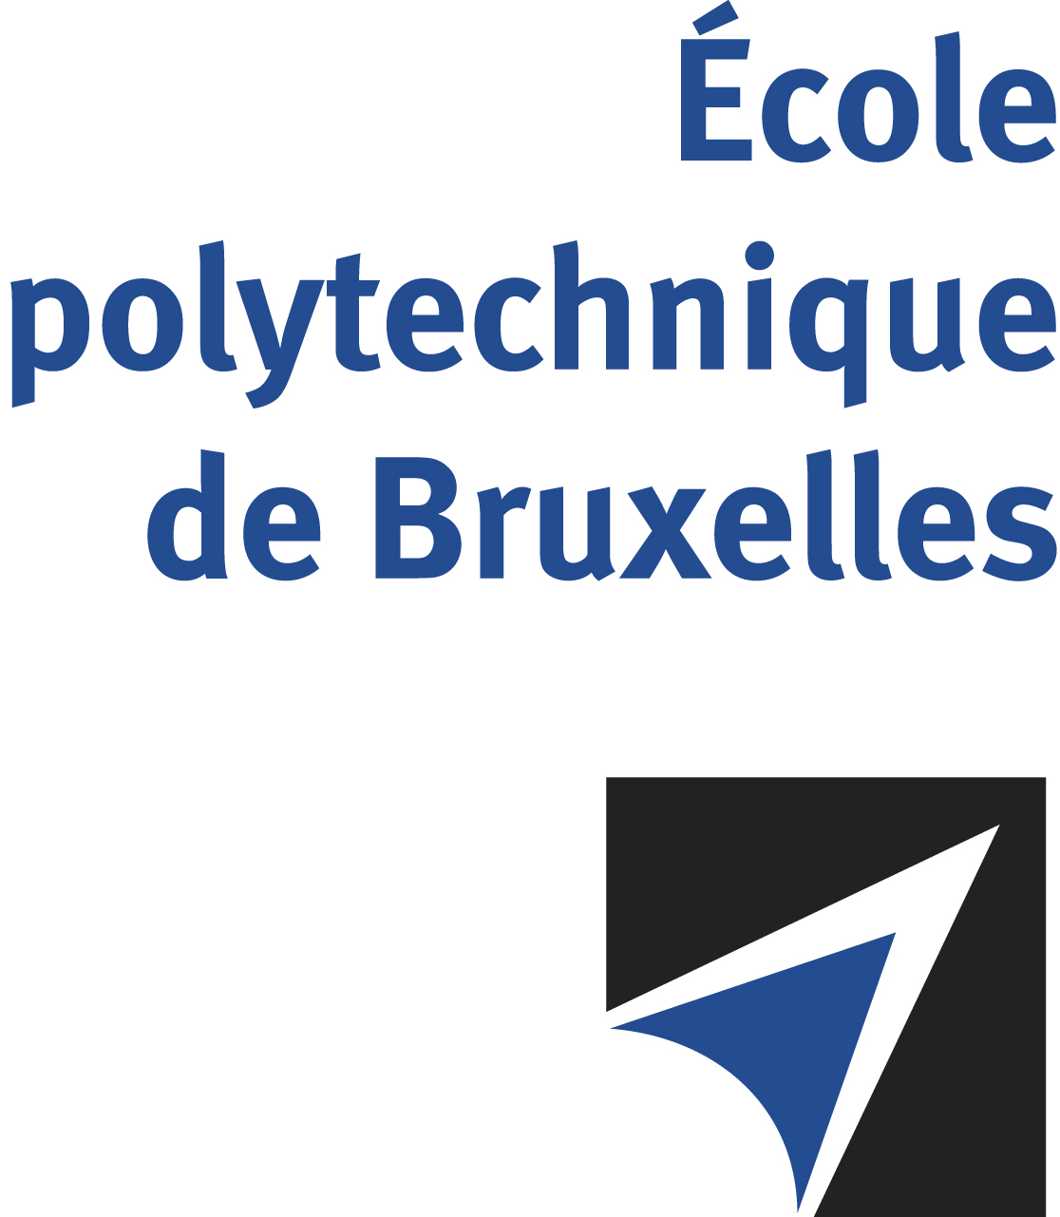

The public defense to obtain the academic degree
of Doctor in Engineering Sciences and Technology
of

Nhât Nam NGUYÊN

will be held on

FRIDAY OCTOBER 25, 2024, AT 5PM
Solbosch Campus
Building D, 2nd level
Room: DC2.206

The defense will also be held on Teams: https://teams.microsoft.com/l/meetup-join/19%3a4ddfe1aacd3b4a738b4508c7517186db%40thread.tacv2/1728319496881?context=%7b%22Tid%22%3a%2230a5145e-75bd-4212-bb02-8ff9c0ea4ae9%22%2c%22Oid%22%3a%223f6c4f42-3640-438a-90d5-9ad5541abf1c%22%7d
Mr Nhât Nam NGUYÊN

will present and defend in public an original thesis entitled:

Continuum states of light exotic nuclei in a microscopic model

Thesis director: Jean-Marc SPARENBERG
Thesis co-director: Pierre DESCOUVEMONT
Department: Physique Nucléaire et Physique Quantique

