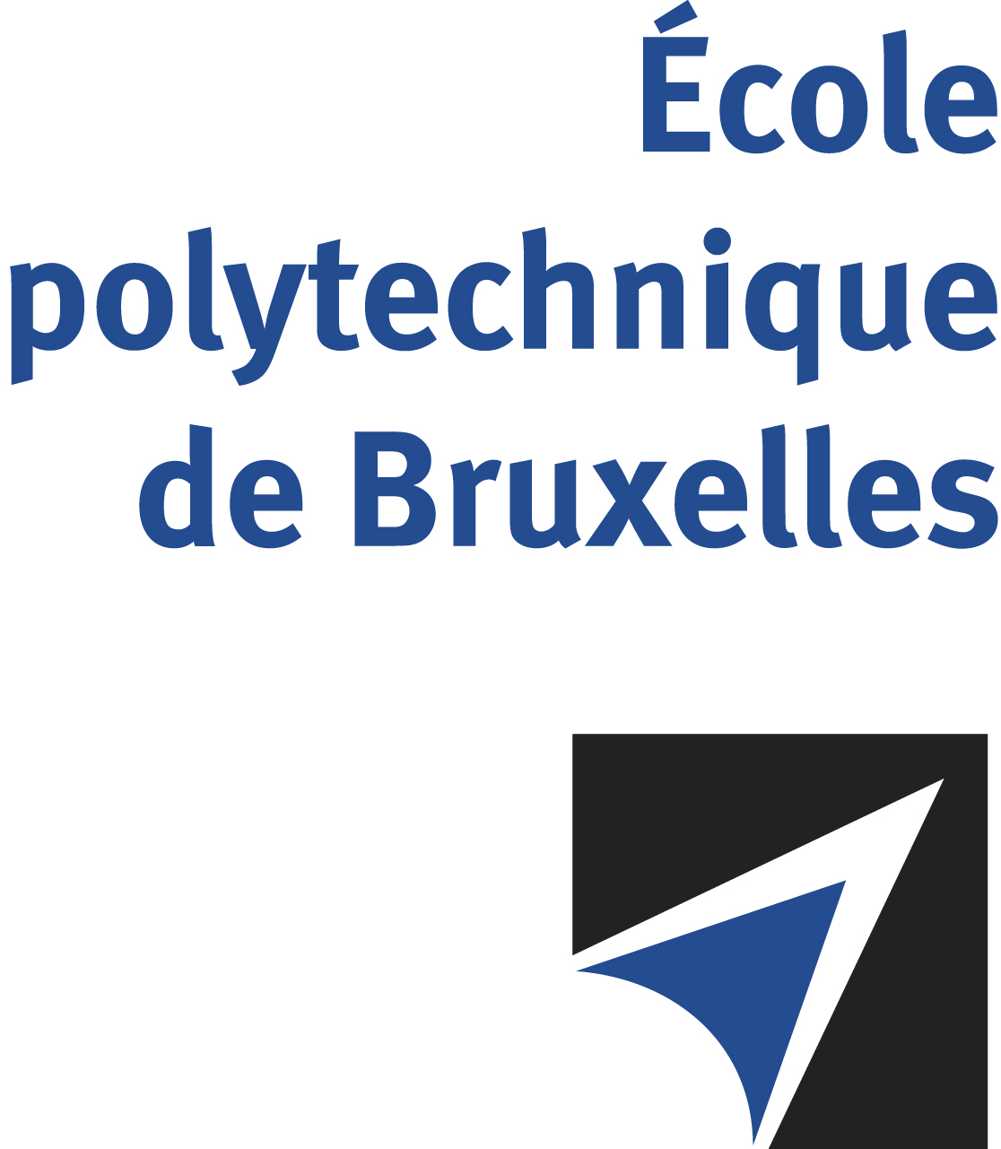

The public defense to obtain the academic degree
of Doctor in Engineering Sciences and Technology
of

Pierre-Alexandre PETITJEAN

will be held on

FRIDAY OCTOBER 18, 2024, AT 4:30PM
Solbosch Campus
Building R42, 5th floor
Room: R42.5.503

The defense will also be held on Teams: https://teams.microsoft.com/l/meetup-join/19%3ameeting_Mjc0Y2QzNWItNmExYy00MjZlLTkxZjAtNmU1ZTZiYzEwZmEz%40thread.v2/0?context=%7b%22Tid%22%3a%2230a5145e-75bd-4212-bb02-8ff9c0ea4ae9%22%2c%22Oid%22%3a%22a9e38e48-5668-49f5-9501-44c7ef0ca06c%22%7d
Mr Pierre-Alexandre PETITJEAN

will present and defend in public an original thesis entitled:

Development and tests of JUNO electronics readout system and study of JUNO performance for core collapse supernova model discrimination

Thesis director: Nicolas PAULY
Thesis co-director: Barbara CLERBAUX
Department: Métrologie nucléaire

