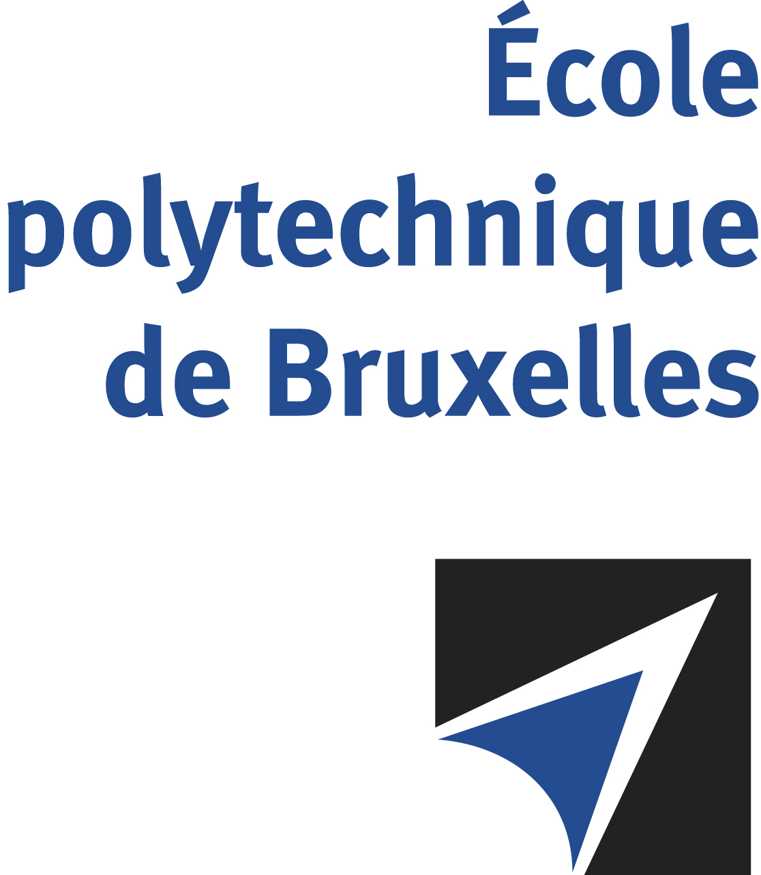

The public defense to obtain the academic degree
of Doctor in Engineering Sciences and Technology
of

Riccardo GELAIN
P
will be held on

MONDAY DECEMBER 9, 2024, AT 4:30PM
Solbosch Campus
Building H, room: H.2.215

The defense will also be held on Teams: https://teams.microsoft.com/l/meetup-join/19%3ameeting_M2Q0OTVlNmMtYmFlMi00ZWJiLWI3MmMtNDFiNWMwOGU4MzAx%40thread.v2/0?context=%7b%22Tid%22%3a%2230a5145e-75bd-4212-bb02-8ff9c0ea4ae9%22%2c%22Oid%22%3a%22bb6a9e3a-eda5-446d-a8a5-e3f7ff0404d0%22%7d
Mr Riccardo GELAIN

will present and defend in public an original thesis entitled:

Experimental investigation of paraffin combustion
in a hybrid rocket slab burner

Thesis director: Patrick HENDRICK
Department: ATM

