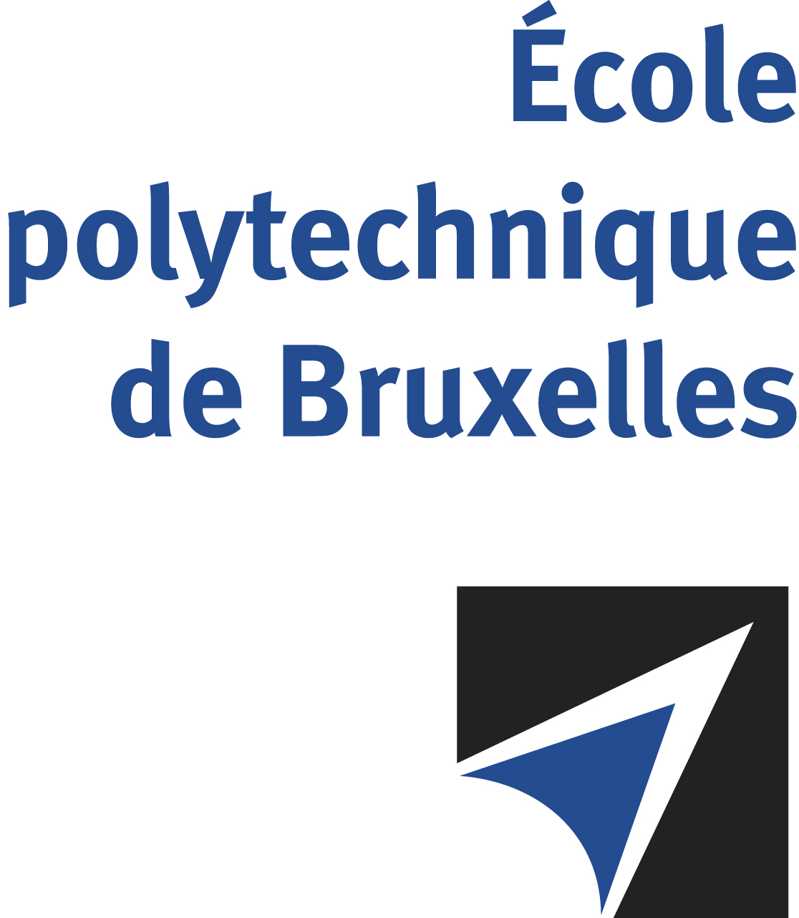

The public defense to obtain the academic degree
of Doctor in Engineering Sciences and Technology
of

Yasin TADAYONRAD

will be held on

THURSDAY SEPTEMBER 19, 2024, AT 3PM
Solbosch Campus
Building K, 4th floor
Room: K.4.401

The defense will also be held on Teams: https://teams.microsoft.com/l/meetup-join/19%3ameeting_MGUxZTUwMGMtNDc5Ny00Y2Q0LTg3YmItYzM3YmNhYWY0YmM2%40thread.v2/0?context=%7b%22Tid%22%3a%2230a5145e-75bd-4212-bb02-8ff9c0ea4ae9%22%2c%22Oid%22%3a%22d224e4f7-2669-4650-831b-ee48c401dc99%22%7d
Mr Yasin TADAYONRAD

will present and defend in public an original thesis entitled:

Development and Application of a New Framework for Integrating Forecasting, Inventory Optimization, and Transportation
Planning in a Supply Chain System

Thesis director: Alassane B. NDIAYE
Department: Qalinca-Labs

