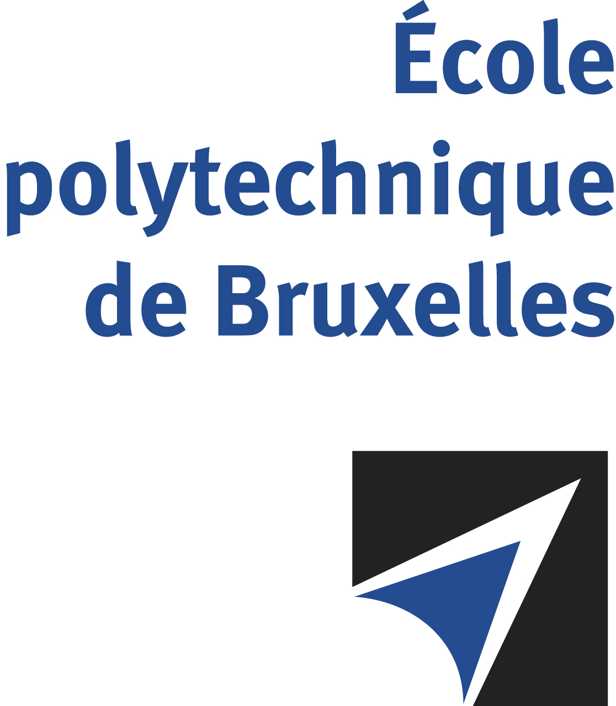

JOINT SUPERVISION
Université libre de Bruxelles – Technical University of Cluj-Napoca

The public defense to obtain the academic degree
of Doctor in Engineering Sciences and Technology

of

Vasile-Sebastian CICEO
Nico Joan BOTEY i BASSOLS las POULVELLARIE
will be held on
FRIDAY NOVEMBER 22nd, 2024, AT 9:30 AM
Solbosch Campus
Building L: first gate: E, second gate: L1.111
Room: L1.111, Labo RED

The defense will also be held on Teams: https://teams.microsoft.com/l/meetup-join/19:meeting_OTgyNmE1NjQtZWNiYi00NmNlLTlkMGQtYzI5NjYxYTdkOGE4@thread.v2/0?context=%7B%22Tid%22:%2230a5145e-75bd-4212-bb02-8ff9c0ea4ae9%22,%22Oid%22:%2283f79ac4-cb42-4ff1-8960-659efbc8d1f2%22%7D
Mr Vasile-Sebastian CICEO

will present and defend in public an original thesis entitled:

System-level Reduced Order Modeling for Automotive Electric Drives

Thesis director: Johan GYSELINCK
TUCN thesis director: Claudia MARTIS
Department: BEAMS

